**Project Estimation:**

The Constructive Cost Model (COCOMO) is an algorithmic software cost

estimation model**.** The software project type that we will be using is organic**.** It is a software project that must be developed within a strongly coupled to hardware environment**.**

• **Effort = PM (person-months needed for project (labor working hours)**)

=**Coefficient<Effort Factor>*(SLOC/1000)^P**

=2.4* (10000/1000)**^**1.05 [**here SLOC =** 10000**, organic co- efficicient**

**effort factor** **is** 2.4 **and P(project complexity which is** 1.05)]

= 26.928 **labor working hours**

• **Development Time, DM= 2.50*(PM)^T**

• =2.50*(26.928)**^**0.38 [**here T for organic is** 0.38] =8.73 **months**

• **Required Number of People, ST (average staffing** **necessary)**

= PM/DM

=26.928/8.73

=3.08

**Project Schudule:**

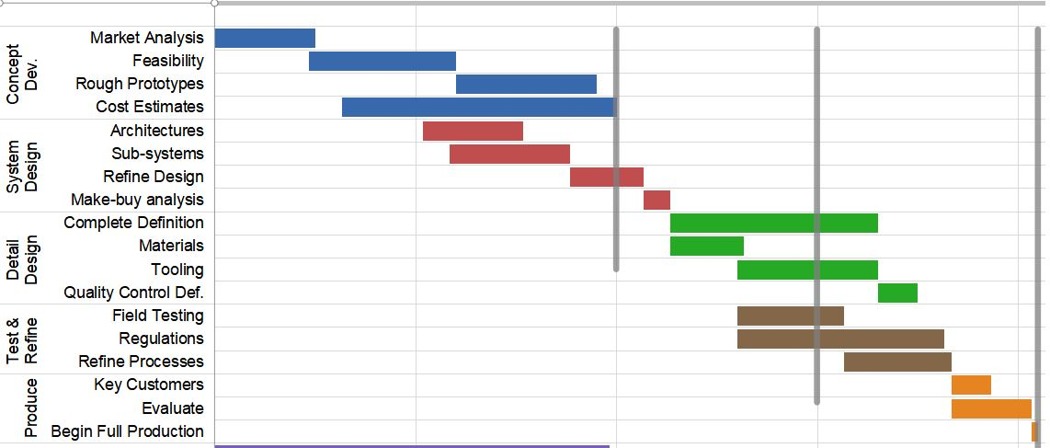

**Time Schudule:**

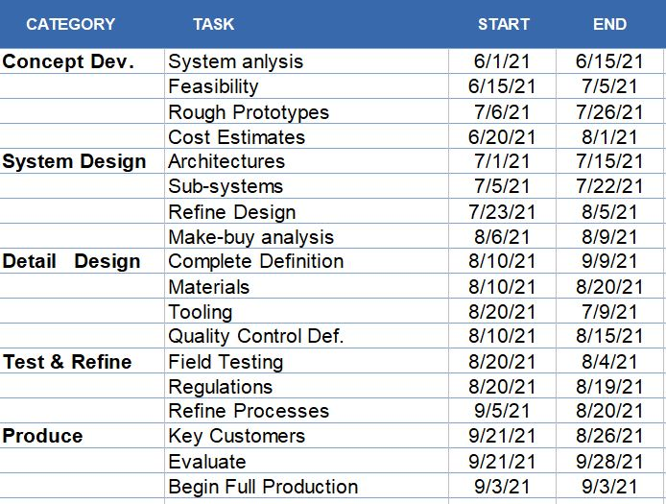

**Milestone:**

